Fullerton School District Projects can be found using the link below:

https://order.e-arc.com/arcEOC/ARCPlanRoom.aspx

The link will bring you to the ARC Webside as shown below, here on the upper right side you will see headings in bright RED.
Click onto PUBLIC Plan-room
Next enter into the Field a reference word of the project you are seeking
(Note arrows in red)

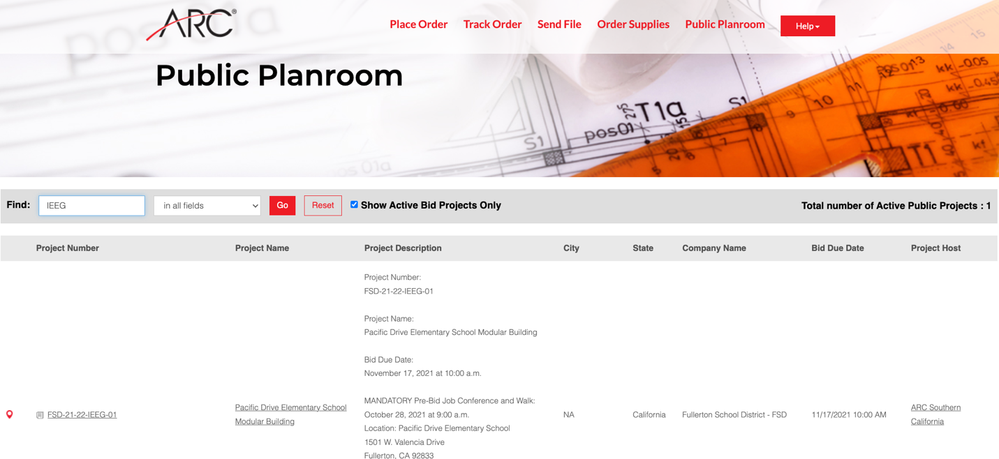
Once the reference information has been entered you will find your project.

Should you have any questions regarding the bid, addendums and/or any other project related information please email.

Mike_mcadam@myfsd.org

